PosgreSQL CONNECT

1. Select Add New Server

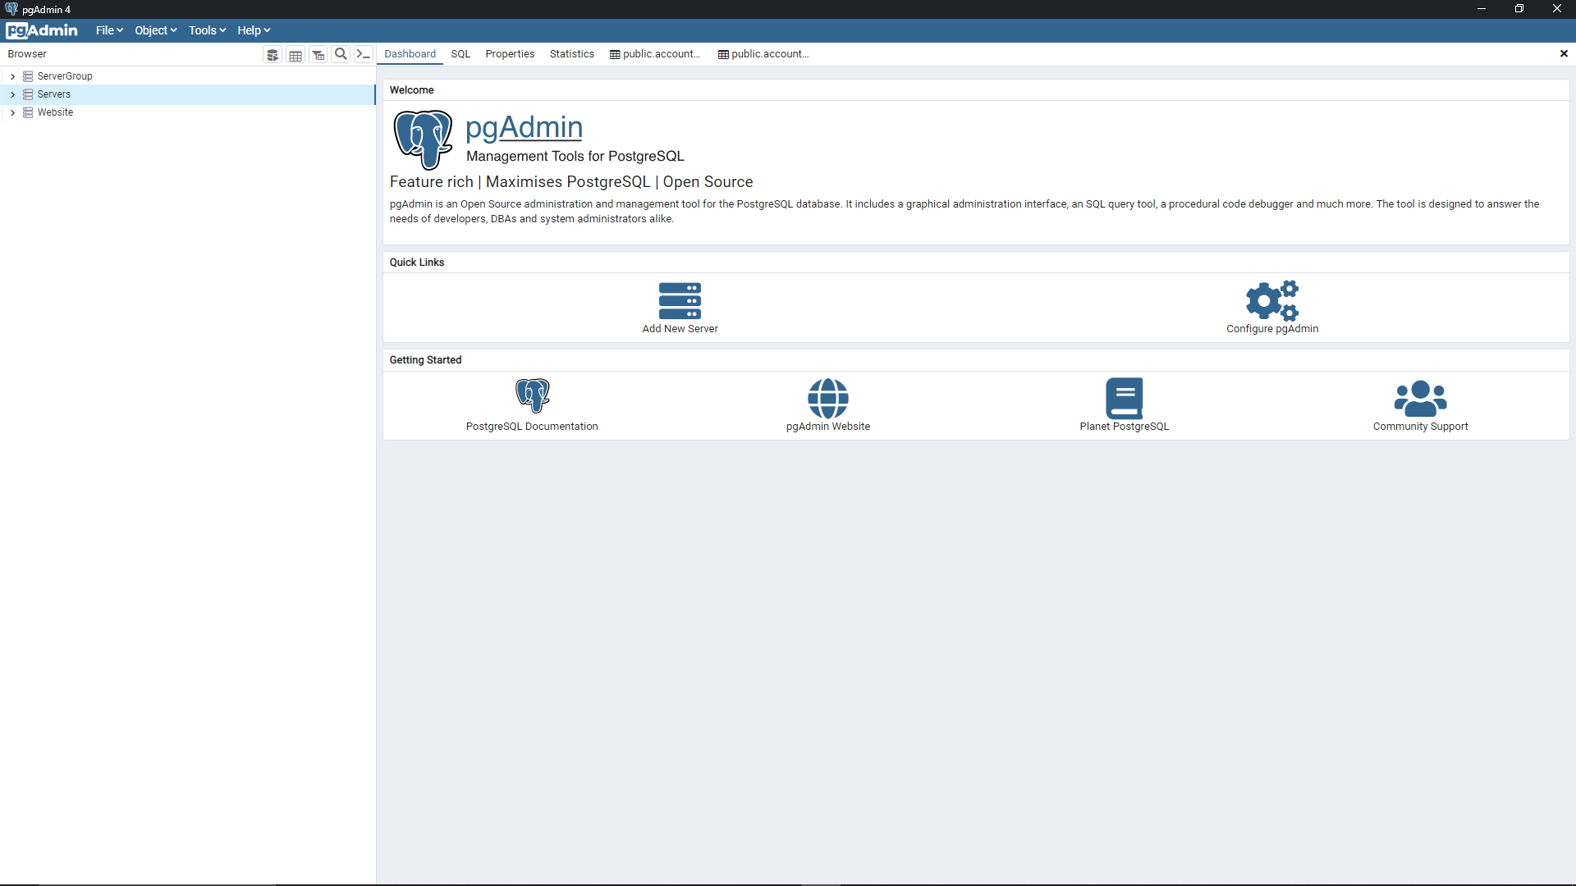

1. After you select Add New Server, Add your desire name of your server

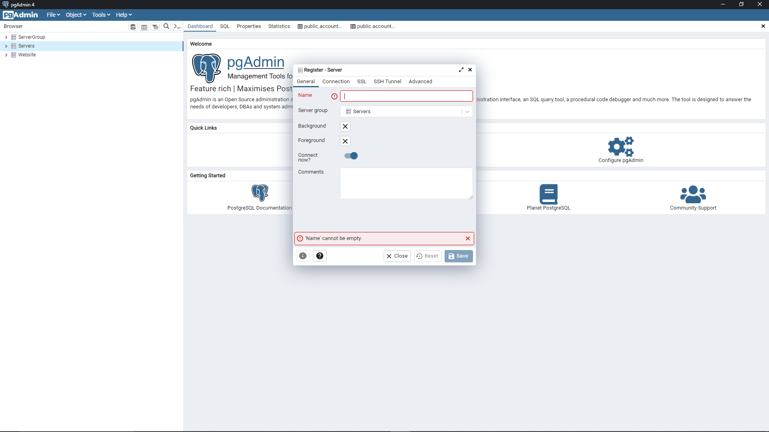

1. After you Add name click Connection and add your/IP , port , username , password

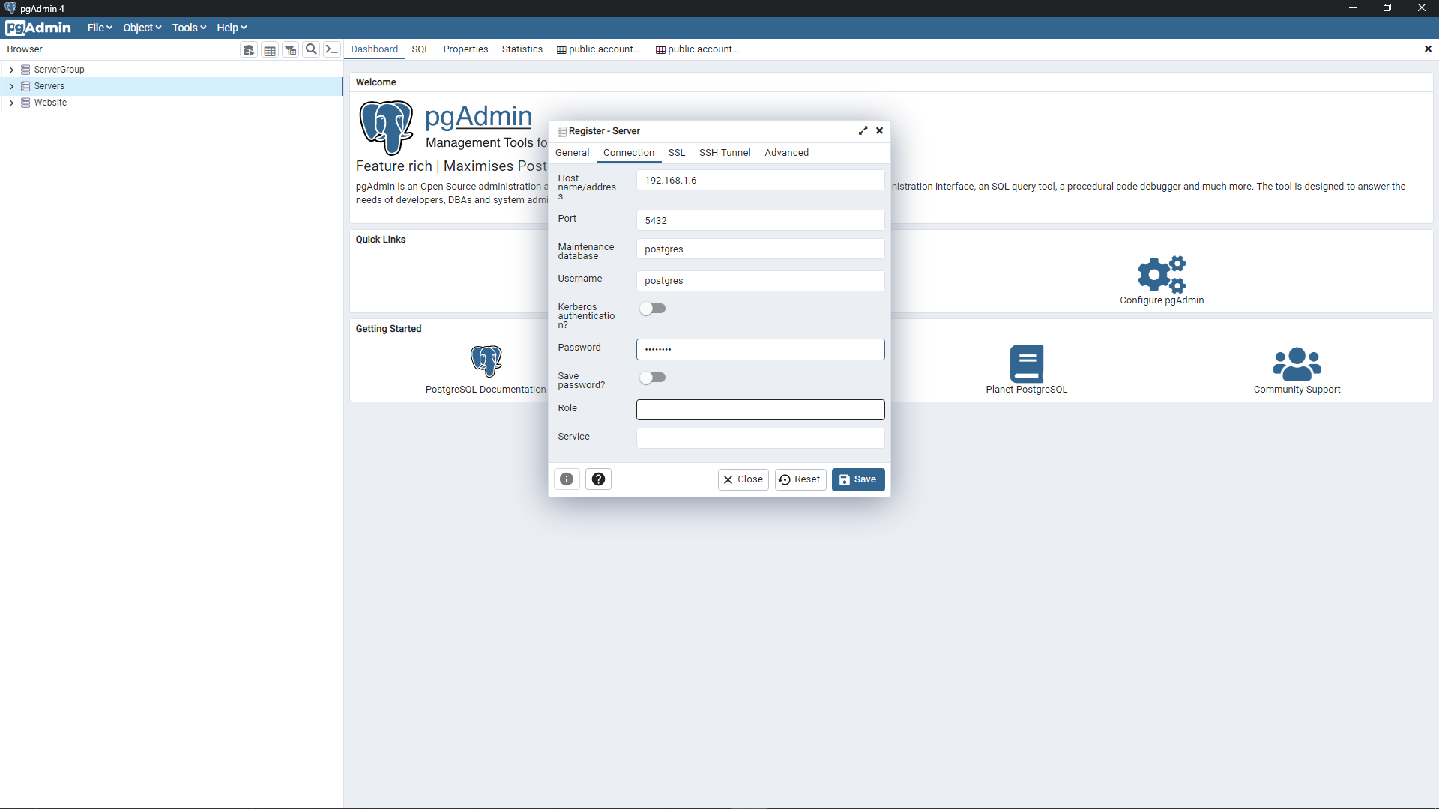  
  
in IP : 192.168.1.6 -> IP: 192.168.1.6 . PASSWORD: POSGRESQL. USERNAME: postgresql.

1. After That Choose/Create your desire Database